**Pizza Sales Data Queries**

### KPI’s

### Total Revenue

SELECT SUM(total_price) AS total_revenue FROM sales_data

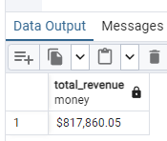

### Average Order Value

SELECT SUM(total_price) / COUNT(DISTINCT order_id) AS avg_order_value FROM sales_data;

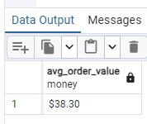

### Total Pizza Sold

SELECT SUM(quantity) AS total_pizza_sold FROM sales_data;

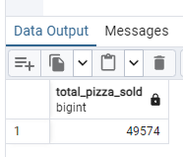

### Total Orders

SELECT COUNT(DISTINCT order_id) AS total_orders FROM sales_data;

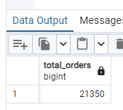

### Average Pizzas Per Order

SELECT CAST(CAST(SUM(quantity) AS DECIMAL(10,2)) / CAST(COUNT(DISTINCT order_id) AS DECIMAL(10,2)) AS DECIMAL(10,2)) AS avg_pizzas_per_order FROM sales_data

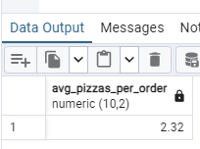

### Daily Trend for Total Orders

SELECT TO_CHAR(order_date,'Day') AS order_day, COUNT(DISTINCT order_id) AS total_orders FROM sales_data GROUP BY TO_CHAR(order_date,'Day')

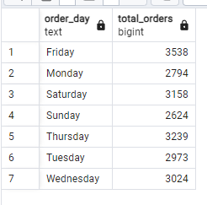

### Monthly Trend for Total Orders

SELECT TO_CHAR(order_date,'Month') AS month_name, COUNT(DISTINCT order_id) AS total_orders FROM sales_data  
GROUP BY TO_CHAR(order_date,'Month')  
ORDER BY total_orders DESC  
  
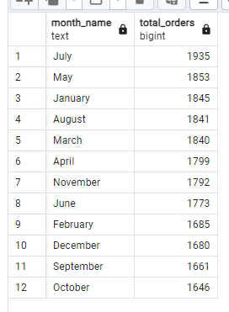

Percentage of Sales by Pizza Category  
  
SELECT pizza_category, SUM(total_price) AS total_sales, SUM(total_price) * 100 / (SELECT SUM(total_price) FROM sales_data) AS PCT FROM sales_data GROUP BY pizza_category

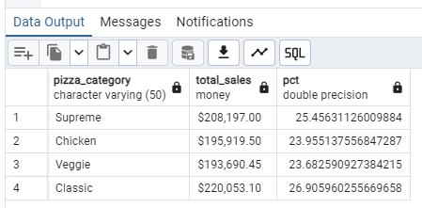

Percentage of Sales by Pizza Size  
  
SELECT pizza_size, SUM(total_price) AS total_sales, SUM(total_price) * 100 / (SELECT SUM(total_price) FROM sales_data) AS PCT FROM sales_data GROUP BY pizza_size  
  
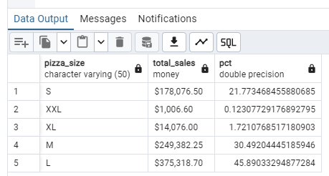

Top Five Pizzas by Total Revenue  
  
SELECT pizza_name, SUM(total_price) AS total_revenue FROM sales_data GROUP BY pizza_name ORDER BY total_revenue DESC LIMIT 5  
  
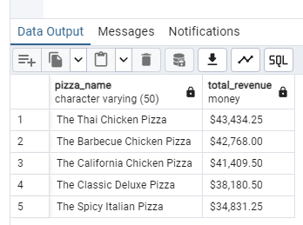

Top Five Pizzas by Quantity  
  
SELECT pizza_name, SUM(quantity) AS total_quantity FROM sales_data GROUP BY pizza_name ORDER BY total_quantity DESC LIMIT 5

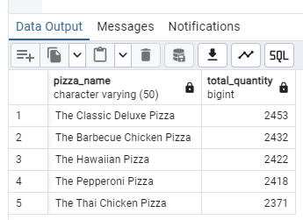

Top Five Pizzas by Total Orders  
  
SELECT pizza_name, COUNT(DISTINCT order_id) AS total_orders FROM sales_data GROUP BY pizza_name ORDER BY total_orders DESC LIMIT 5

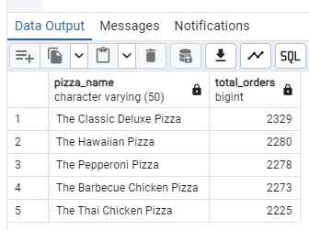

Bottom Five Pizzas by Total Revenue  
  
SELECT pizza_name, SUM(total_price) AS total_revenue FROM sales_data GROUP BY pizza_name ORDER BY total_revenue ASC LIMIT 5  
  
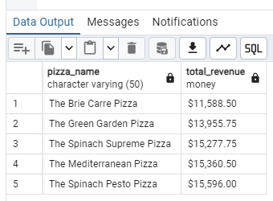

Bottom Five Pizza by Total Quantity  
  
SELECT pizza_name, SUM(quantity) AS total_quantity FROM sales_data GROUP BY pizza_name ORDER BY total_quantity ASC LIMIT 5  
  
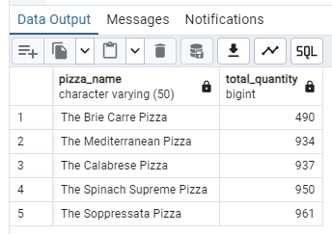

Bottom Five Pizza by Total Orders  
  
SELECT pizza_name, COUNT(DISTINCT order_id) AS total_orders FROM sales_data GROUP BY pizza_name ORDER BY total_orders ASC LIMIT 5

